**HW E**

1. Pirate Mfg. Company is a manufacturer of many different products that they sell to other businesses. You have been asked to design a database for a portion of their operation. The Data Model below has been created and now you are to complete the database design. As follows:
2. Draw the design to include:
   1. Show Primary key(s) (see example below)
   2. 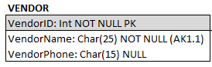Add Foreign Keys
   3. Add any Alternate Keys
   4. Add the Data Type
   5. Indicate NULL status

Use Visio to create your database tables and copy paste it here.

**Data Model**

1. The final database design for Ajax Company is now ready for you to document each table and relationship as follows:

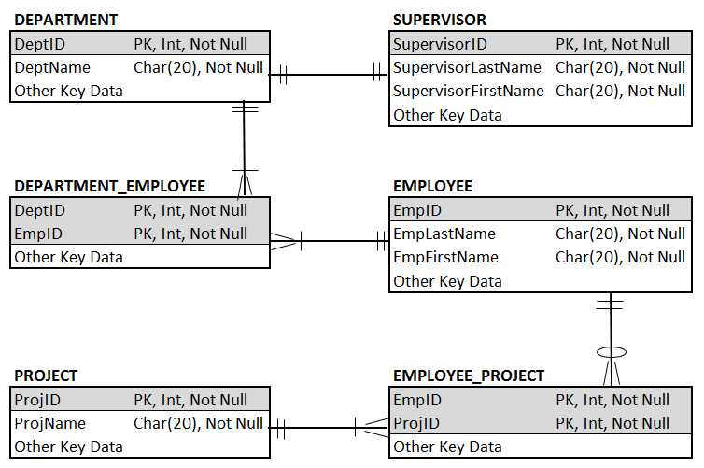

1. Enter the documentation on each table below based on the design above.
2. Enter the documentation for each relationship in the matrix that follows the tables.
3. Omit the “Other Key Data”

|  |  |  |  |  |
| --- | --- | --- | --- | --- |
| **Table**: |  |  |  |  |
| **Column Name** | **Type** | **Key** | **NULL Status** | **Remarks** |
|  |  |  |  |  |
|  |  |  |  |  |
|  |  |  |  |  |
|  |  |  |  |  |
|  |  |  |  |  |
|  |  |  |  |  |
|  |  |  |  |  |

|  |  |  |  |  |
| --- | --- | --- | --- | --- |
| **Table**: |  |  |  |  |
| **Column Name** | **Type** | **Key** | **NULL Status** | **Remarks** |
|  |  |  |  |  |
|  |  |  |  |  |
|  |  |  |  |  |
|  |  |  |  |  |
|  |  |  |  |  |
|  |  |  |  |  |
|  |  |  |  |  |

|  |  |  |  |  |
| --- | --- | --- | --- | --- |
| **Table**: |  |  |  |  |
| **Column Name** | **Type** | **Key** | **NULL Status** | **Remarks** |
|  |  |  |  |  |
|  |  |  |  |  |
|  |  |  |  |  |
|  |  |  |  |  |
|  |  |  |  |  |
|  |  |  |  |  |
|  |  |  |  |  |

|  |  |  |  |  |
| --- | --- | --- | --- | --- |
| **Table**: |  |  |  |  |
| **Column Name** | **Type** | **Key** | **NULL Status** | **Remarks** |
|  |  |  |  |  |
|  |  |  |  |  |
|  |  |  |  |  |
|  |  |  |  |  |
|  |  |  |  |  |
|  |  |  |  |  |

|  |  |  |  |  |
| --- | --- | --- | --- | --- |
| **Table**: |  |  |  |  |
| **Column Name** | **Type** | **Key** | **NULL Status** | **Remarks** |
|  |  |  |  |  |
|  |  |  |  |  |
|  |  |  |  |  |
|  |  |  |  |  |
|  |  |  |  |  |
|  |  |  |  |  |
|  |  |  |  |  |

|  |  |  |  |  |
| --- | --- | --- | --- | --- |
| **Table**: |  |  |  |  |
| **Column Name** | **Type** | **Key** | **NULL Status** | **Remarks** |
|  |  |  |  |  |
|  |  |  |  |  |
|  |  |  |  |  |
|  |  |  |  |  |
|  |  |  |  |  |
|  |  |  |  |  |
|  |  |  |  |  |

**Relationships**

|  |  |  |  |  |
| --- | --- | --- | --- | --- |
| **Relationship** | | **Cardinality** | | |
| **Parent** | **Child** | **Type** | **MAX** | **MIN** |
| Department | Supervisor |  |  |  |
| Department | Employee |  |  |  |
| Supervisor | Employee |  |  |  |
| Employee | Project |  |  |  |
|  |  |  |  |  |
|  |  |  |  |  |
|  |  |  |  |  |